**GITHUB**

* Create Account on Github.com
* Click on this Link <https://github.com/>
* Sign up with your credential (email,Password)
* Create repository by clicking on Create repository button on top left.

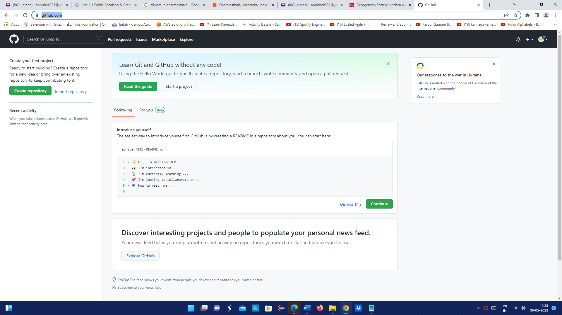

Create new by giving some meaningful name

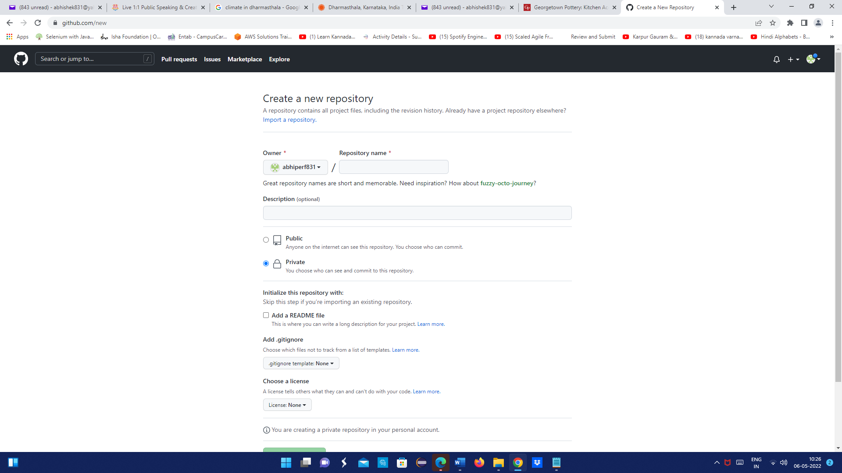

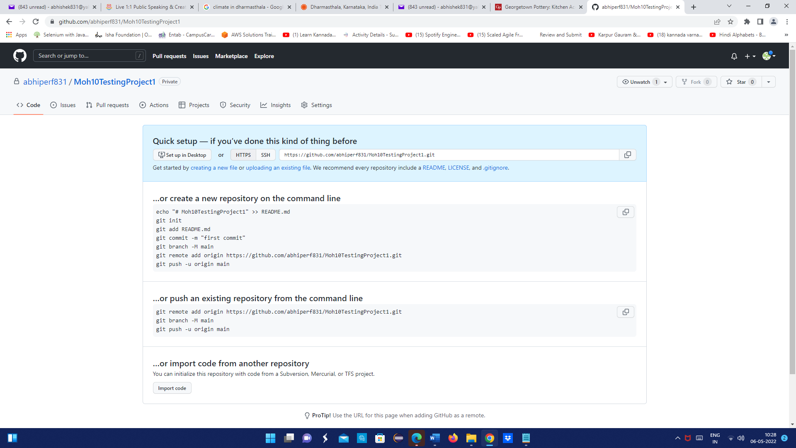

Click for desktop setup (Optional)

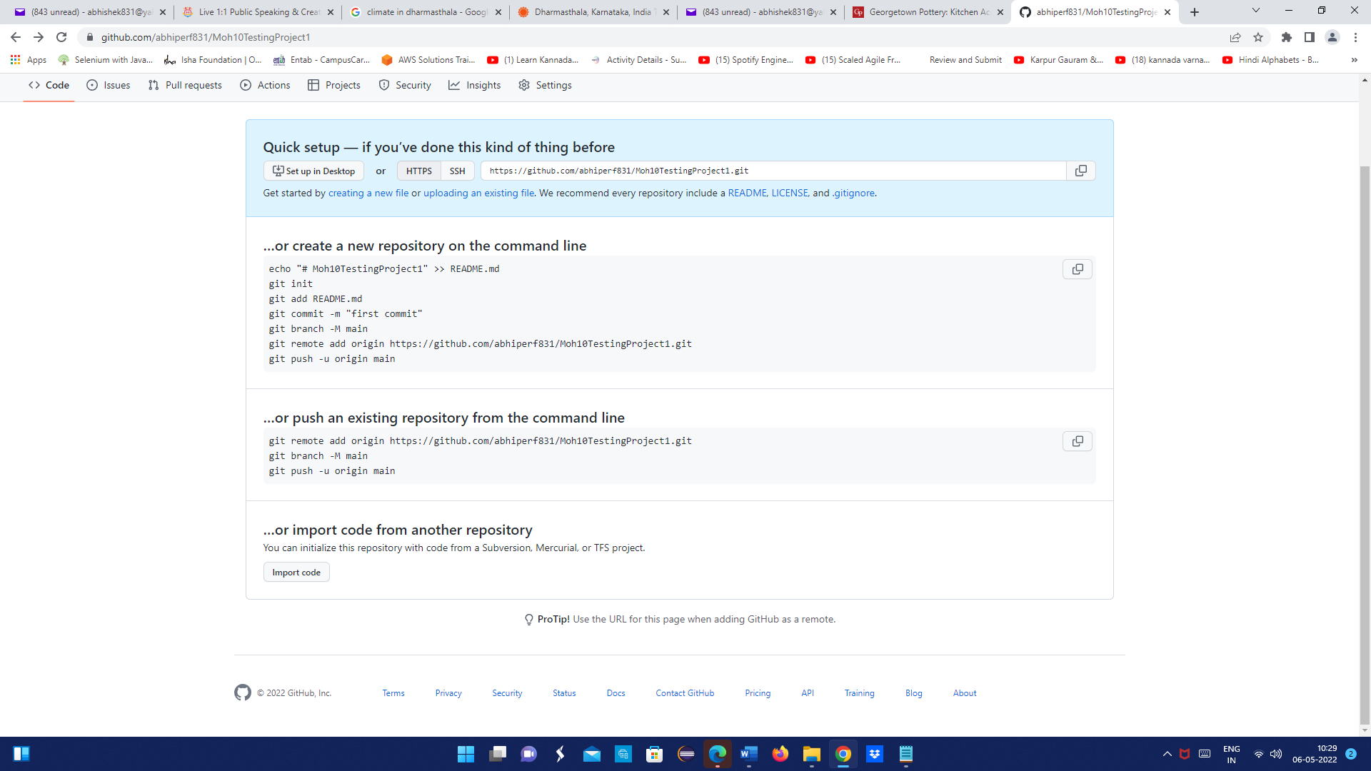

Add your repository

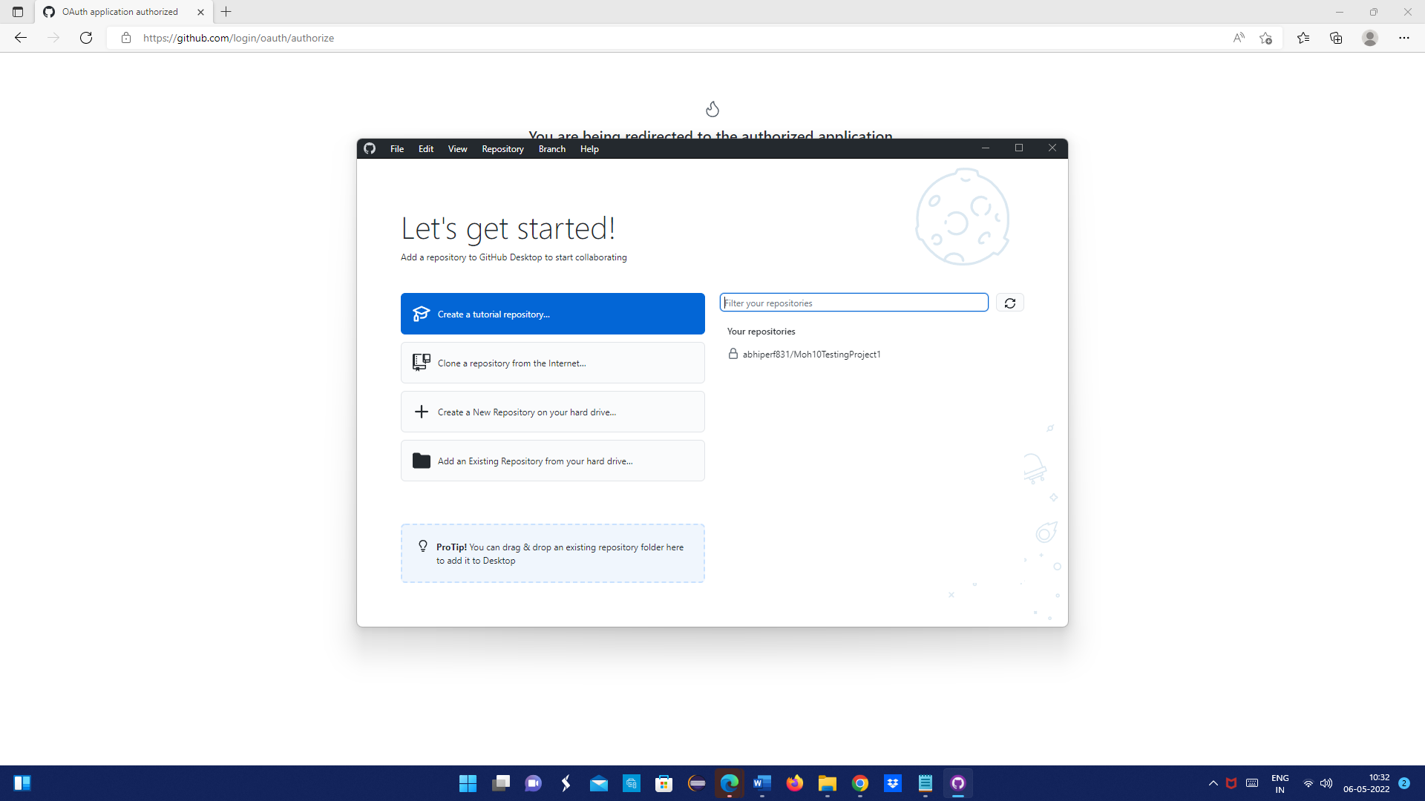

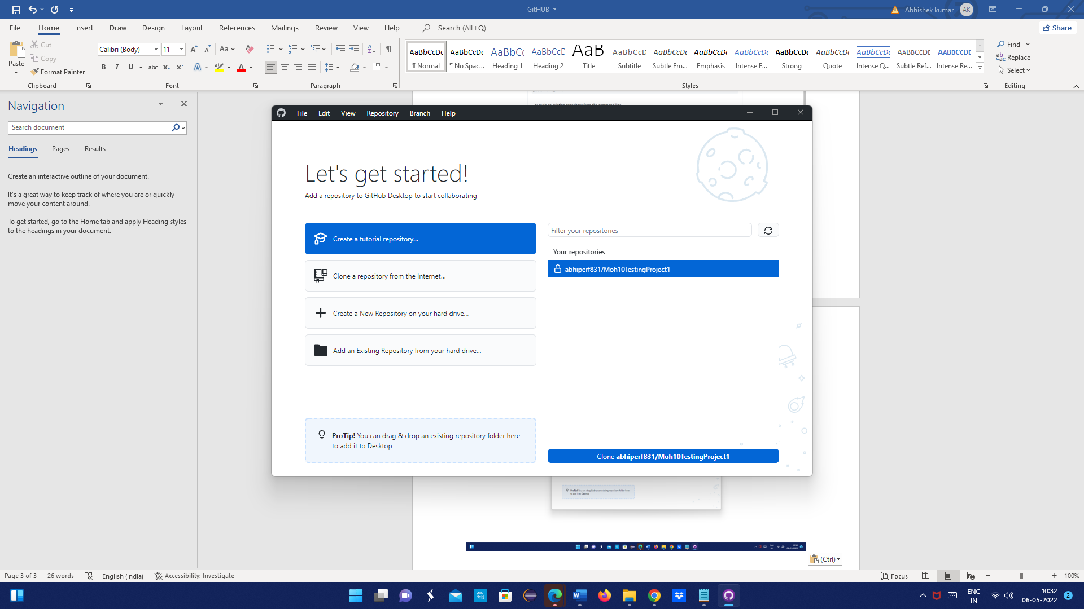

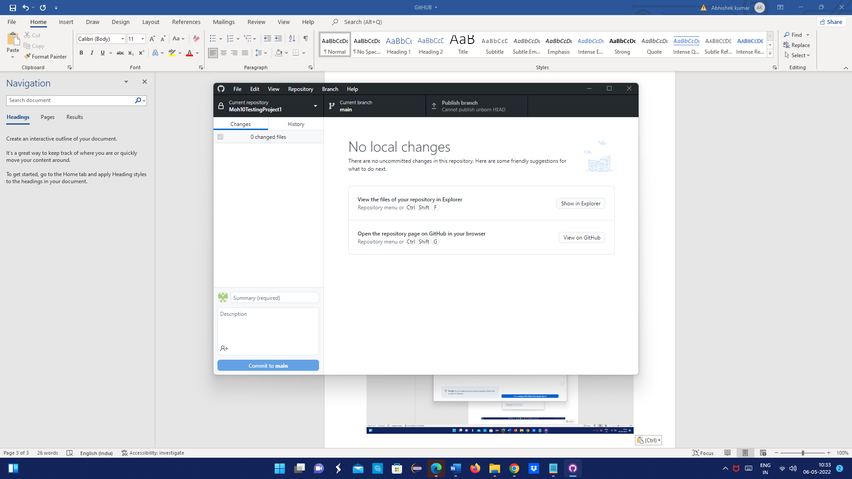

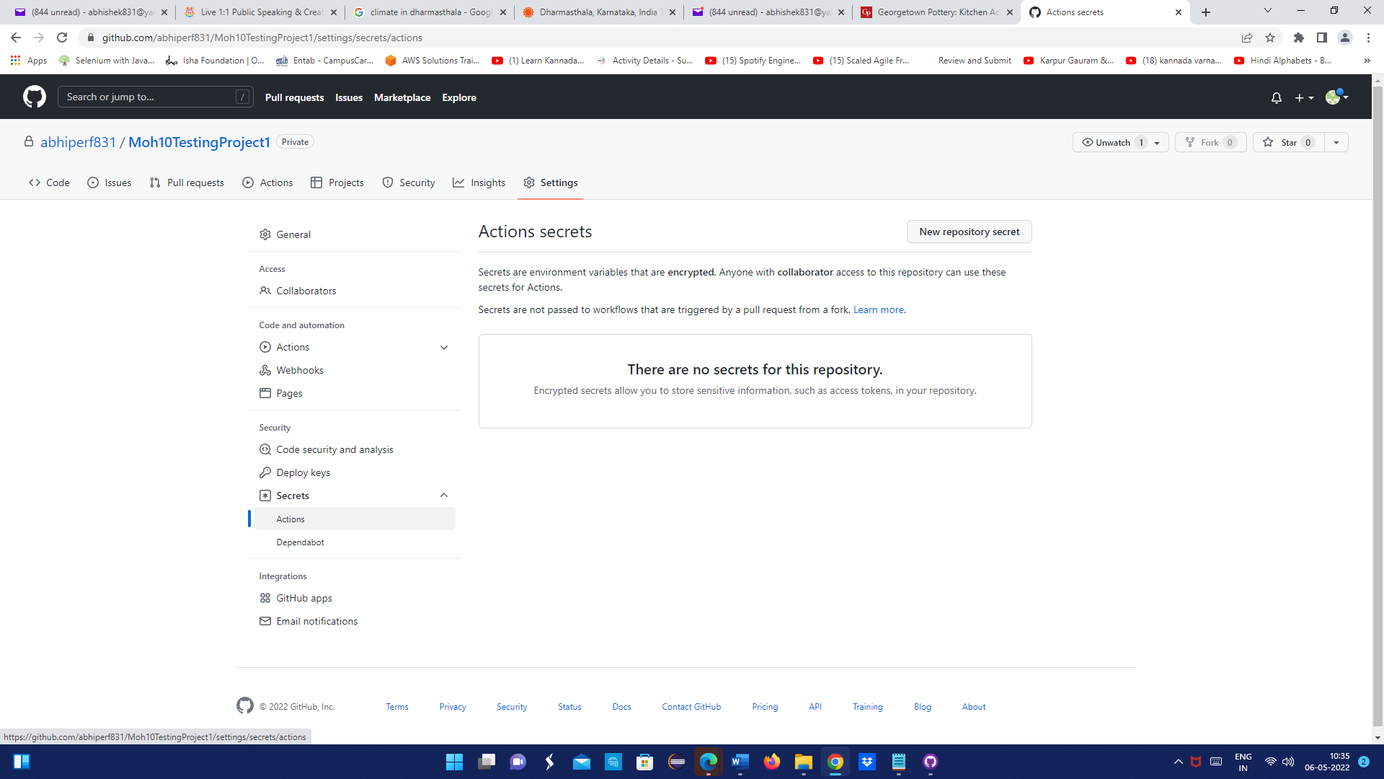

**Token generation process (Optional)**

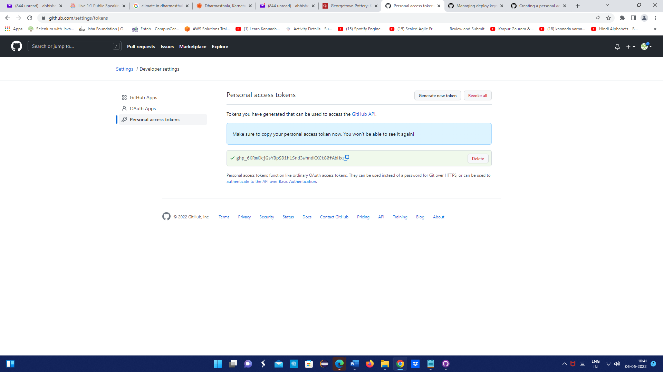

Detail process to create personal token

https://docs.github.com/en/authentication/keeping-your-account-and-data-secure/creating-a-personal-access-token

**Push Code to Git hub**

1. Initialize git repository using git command: git init
2. Add all the files to be pushed using: git add
3. Commit pushed files using: git command -m “commit message”
4. Branch on which code needs to be push: git branch -m main
5. Push code using: it push -u origin main

**Jenkin Integration**

1. Go to Jenkin configuration
2. Go to source code Management section
3. Select Git option Enter Repository URL
4. Open Credentials dropdown and select the appropriate option
5. Enter Branch Under Branch Specifier>> click on Save configuration.
6. Click on Apply button
7. Now jenkin will take the source code from GIThub repository and will run the test suites